
A PROJECT REPORT ON
DATA-DRIVEN ENERGY AUDIT AND CARBON FOOTPRINT REDUCTION IN UNIVERSITY CAMPUS BUILDINGS: A CASE STUDY

By,
Anushka Shinde
(SRN: 31242632)
Project No : 1

Guided By
Dr. Anupriya Kamble
Course Name: Research Methedology
For the Programme

B.Sc. - COMPUTER SCIENCE
Third Year
In the Year
2026-27

Pursued in
Department of Computer Science
Faculty of Science & Technology
Vishwakarma University, Pune
Abstract
This case study demonstrates a data-driven approach for identifying potential heating, ventilation and air-conditioning (HVAC) energy waste in university campus buildings. Hourly electricity, HVAC load, occupancy estimates, outdoor temperature and operating schedule data are analyzed in Excel and Python for 1 October–30 November 2026. Because actual campus smart-meter data were not supplied, a synthetic dataset covering three illustrative buildings is used to demonstrate the workflow. The analysis estimates total electricity use of 160,312 kWh, HVAC electricity use of 80,307 kWh (50.1%), and baseline emissions of 112,218 kg CO₂e using an illustrative emission factor of 0.70 kg CO₂e/kWh. A proposed operational scenario combines tighter after-hours scheduling, setpoint optimization and preventive maintenance. Under stated assumptions, the model estimates a potential electricity reduction of 11.2% and avoided emissions of 12,585 kg CO₂e. These are scenario outputs, not verified savings. The study recommends validating the opportunity with actual meter data and a controlled pilot before reporting a 15% reduction as achieved.

Keywords
Energy audit; HVAC; smart meter; carbon footprint; energy efficiency; Python; Excel; university campus.
1. Introduction
Buildings consume electricity for cooling, ventilation, lighting, computing and other services. HVAC systems can be a significant and controllable load, particularly when systems operate during low occupancy, schedules are not aligned with academic activities, or setpoints and maintenance practices are inefficient. Smart-meter data can reveal hourly patterns that monthly utility bills cannot show. A practical energy audit combines consumption data with operating schedules and occupancy information to identify opportunities for operational improvements.
This project develops a reproducible, data-driven workflow for a university campus case study. It focuses on identifying possible HVAC waste and estimating the effect of operational adjustments while preserving indoor comfort and required ventilation.
2. Problem Statement
Campus building energy use may be higher than necessary when HVAC equipment operates outside occupied hours, cooling setpoints are unnecessarily low, or equipment performance degrades. Without interval data and a structured analysis, facilities teams may struggle to prioritize corrective actions or quantify potential carbon benefits.

3. Aim and Objectives
- Analyze hourly building electricity and HVAC consumption over the project period.
- Identify time-of-day and building-level patterns that may indicate avoidable HVAC energy use.
- Estimate associated operational carbon emissions using a clearly stated emissions factor.
- Propose measurable adjustments to operating schedules, setpoints and maintenance.
- Develop a transparent scenario model targeting up to 15% electricity-related carbon reduction, then explain how to validate it with real data.

14. Scope and Limitations
The demonstration covers three illustrative buildings and hourly records from 1 October through 30 November 2026. The dataset is synthetic and is not a record of Vishwakarma University or any real campus. Occupancy is estimated, HVAC energy is modeled, and the emission factor is illustrative. Results must not be presented as measured university performance. Actual savings depend on weather, occupancy, equipment, control sequences, grid emissions, and operational constraints.
5. Dataset and Variables
The generated CSV contains 4,392 hourly building records (61 days × 24 hours × 3 buildings). It includes timestamp, building, weekday/weekend label, hour, outdoor temperature, estimated occupancy, HVAC setpoint, HVAC schedule state, HVAC kWh, other electricity kWh, total electricity kWh and an illustrative emissions factor. Derived fields flag after-hours records and calculate carbon-equivalent emissions.
- Timestamp and building: identify the interval and building.
- HVAC kWh and total electricity kWh: modeled energy use for each building-hour.
- Outdoor temperature and occupancy estimate: contextual variables for interpreting load.
- HVAC setpoint and scheduled-on flag: allow schedule and control review.
- Emissions factor: assumed 0.70 kg CO₂e per kWh solely for demonstration.

6. Methodology

6.1 Data preparation
The CSV is loaded with pandas. Timestamps are parsed, missing values and duplicate intervals should be checked for real data, and records are grouped by building, date and hour. The demonstration dataset is generated with complete hourly intervals; a real implementation should document all cleaning decisions.

6.2 Exploratory analysis
The analysis calculates total and HVAC electricity, HVAC share of total electricity, after-hours HVAC electricity, daily trends, average hourly HVAC load and building-level comparisons. Plots help locate persistent overnight loads, unusual peaks and differences in operating patterns.

6.3 Carbon accounting
Operational electricity emissions are estimated as electricity consumption (kWh) multiplied by an emissions factor (kg CO₂e/kWh). The factor used here is 0.70 kg CO₂e/kWh as an illustrative assumption only. For a formal study, use the applicable official grid factor for the relevant reporting year and state whether it is location-based or market-based.

6.4 Scenario calculation
The illustrative scenario assumes 35% of identified after-hours HVAC electricity can be avoided through schedule alignment, plus 5% HVAC savings from setpoint optimization and 2.5% from maintenance. The components may overlap, so this is a planning estimate rather than an engineering guarantee. The model caps savings at 15% of total electricity to align the scenario with the project target. Actual savings should be calculated from weather- and occupancy-adjusted pre/post measurements.
7. Results (Synthetic Demonstration)
The synthetic dataset totals 160,312 kWh of electricity, of which 80,307 kWh (50.1%) is attributed to HVAC. Estimated after-hours HVAC consumption is 34,157 kWh. Applying the illustrative factor yields 112,218 kg CO₂e baseline emissions. The scenario model estimates 17,978 kWh of avoided electricity, equal to 11.2% of modeled baseline use, and 12,585 kg CO₂e of avoided emissions. These values demonstrate the calculation method only and are not verified outcomes.
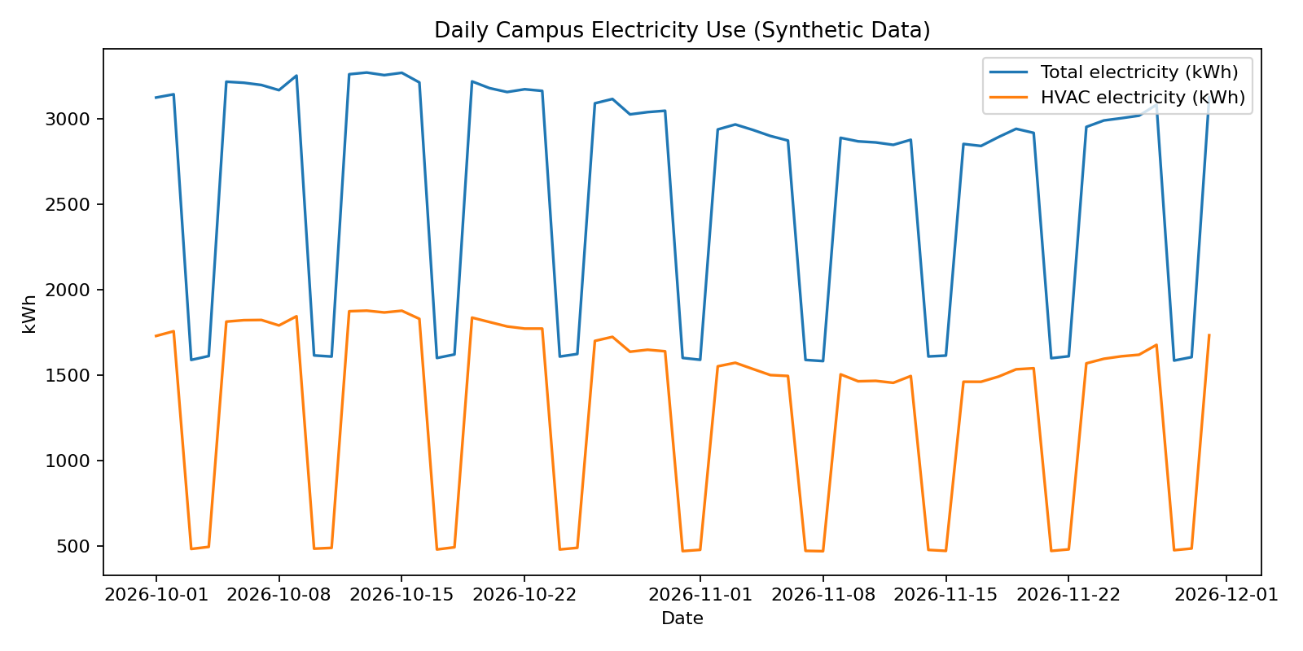
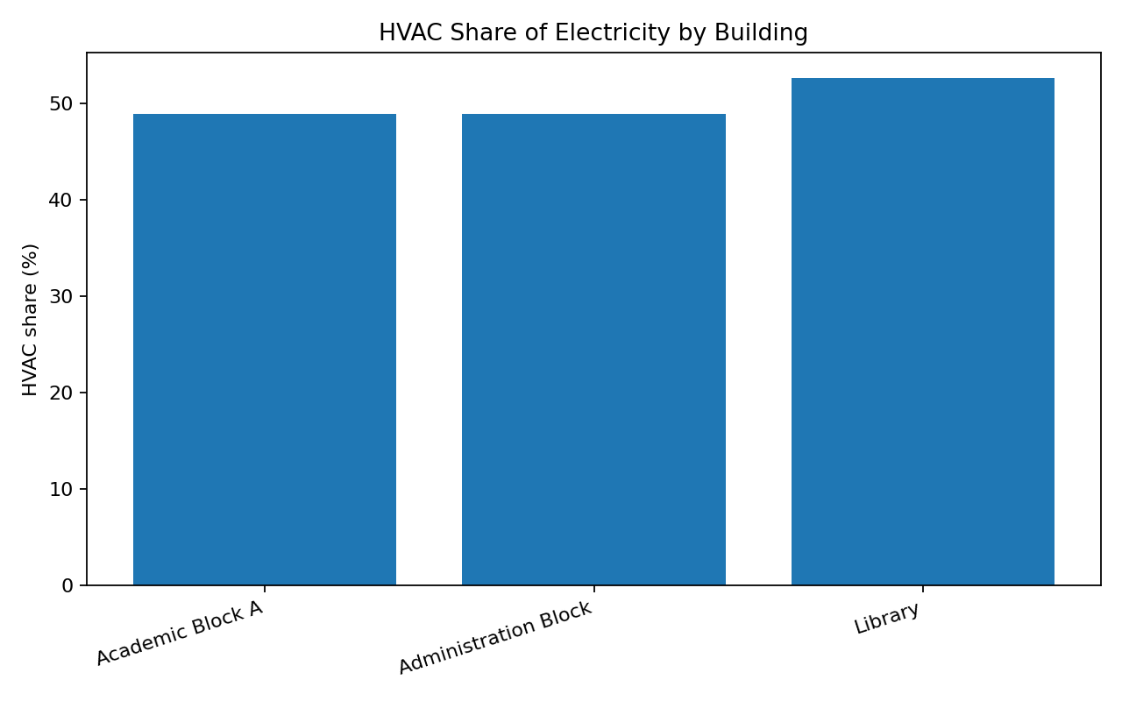
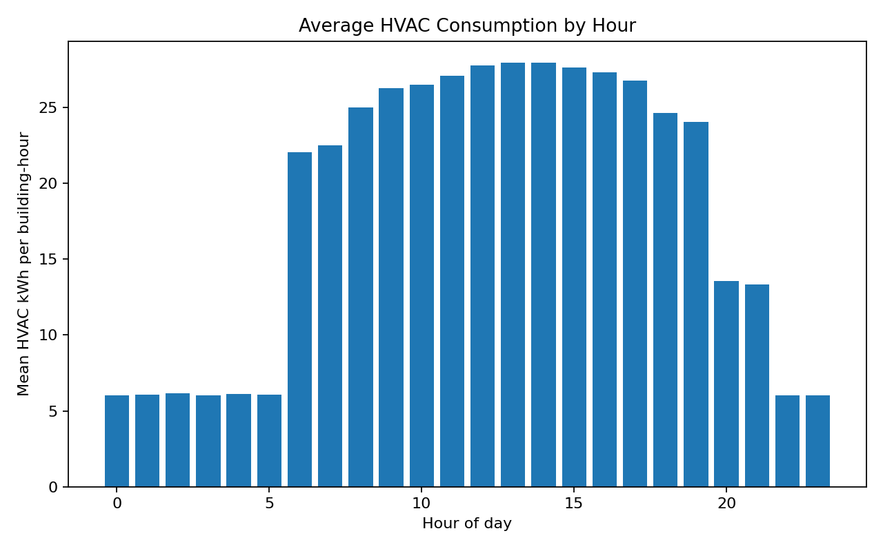
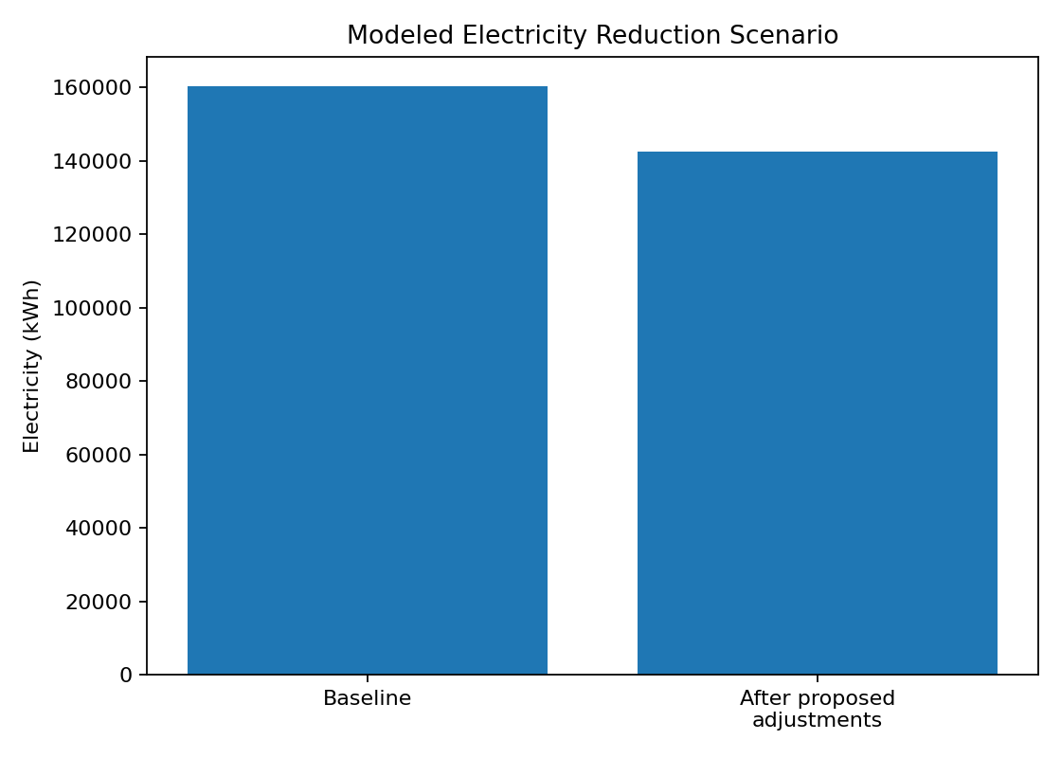

8. Recommendations
- Align HVAC schedules with occupancy: Review timetables, room bookings and access hours. Switch off or reduce HVAC in unoccupied areas when safe and compliant; retain required ventilation and humidity controls.
- Review cooling setpoints: Avoid excessive cooling. Trial a modest setpoint increase (for example, 1°C where comfort standards allow), then monitor comfort complaints and humidity.
- Use start/stop optimization: Avoid starting systems too early or running them late. Use building-specific warm-up/cool-down periods rather than one campus-wide schedule.
- Improve preventive maintenance: Inspect filters, coils, belts, refrigerant charge, sensors, dampers and controls. Record maintenance actions and compare energy before and after.
- Create exception alerts: Flag high overnight baseloads, HVAC operation on weekends, abrupt load changes and deviations from expected profiles.
- Measure and verify: Use a two- to four-week pilot in selected buildings, normalize for weather and occupancy, and compare with a baseline before scaling.

9. Implementation Plan
Period | Activity | Deliverable
1–7 October | Confirm building list, meters, units, time zone and data permissions | Data inventory and data dictionary
8–15 October | Collect and clean interval data; inspect gaps and duplicates | Validated analysis dataset
16–25 October | Explore daily/hourly trends and HVAC after-hours patterns | Charts and anomaly shortlist
26 October–5 November | Review schedules, setpoints and maintenance with facilities team | Prioritized actions
6–20 November | Pilot approved changes in selected areas and record comfort/occupancy | Pilot log and pre/post data
21–30 November | Estimate normalized savings, document limitations and present findings | Final report and presentation

10. Evaluation and Verification
A 15% reduction should be treated as a target, not a guaranteed result. Establish a baseline using actual interval data and define a comparison period. Compare equivalent days and hours, adjust for outdoor temperature and occupancy where possible, document any changes in building use, and monitor thermal comfort and indoor-air-quality requirements. Report both absolute kWh and percentage change, with uncertainty and data-quality limitations.
11. Ethical, Operational and Data Considerations
Obtain authorization before accessing meter or building-management data. Avoid collecting personally identifiable occupancy data; use aggregated counts where possible. Coordinate changes with facilities staff, protect ventilation and safety requirements, and do not make comfort-sensitive control changes without monitoring and approval.
12. Conclusion
This project demonstrates how smart-meter analytics can support a campus energy audit by exposing hourly patterns, estimating electricity-related emissions and prioritizing operational improvements. The synthetic case study illustrates a transparent pathway toward a 15% reduction target, especially through schedule alignment, setpoint review and maintenance. Because the data are simulated and intervention assumptions may overlap, the modeled result cannot be claimed as an achieved reduction. The next step is to replace the sample dataset with authorized real meter data and verify savings through a monitored pilot.
13. Future Scope
- Integrate building-management-system data and real smart-meter interval readings.
- Use regression or change-point models to normalize consumption for weather and occupancy.
- Develop automated dashboards and alerts for anomalous after-hours use.
- Extend the analysis to lighting, plug loads, water heating and renewable energy.
- Conduct a formal measurement-and-verification study after interventions.

References
- ASHRAE. (2023). ASHRAE Guideline 14: Measurement of Energy, Demand, and Water Savings. American Society of Heating, Refrigerating and Air-Conditioning Engineers.
- Efficiency Valuation Organization. (2022). International Performance Measurement and Verification Protocol (IPMVP): Core Concepts.
- U.S. Environmental Protection Agency. Greenhouse Gas Equivalencies Calculator and electricity emissions resources. Use the applicable local official grid factor for an India-based campus study.
- Pandas development team. pandas documentation. https://pandas.pydata.org/docs/
- Matplotlib development team. Matplotlib documentation. https://matplotlib.org/stable/

